 | Score | Score | Score | 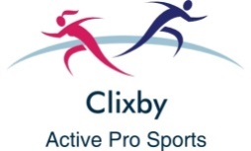  Best
1. 5m Shuttle Sprints
2. Target Throwing
3. Standing Long Jump
4. Distance Run
5. Egg & Spoon
6. Speed Bounce
7. Skipping
8. Tennis Racket Bounce
9. Hurdles
10. Hopping
TOTAL

